CHEAH CHONG GEE (030314) MOHAMAD ALIF IRFAN BIN MOHAMAD SABRI (031545)
MIS DEPARTMENT

NEWTON RESEARCH & DEVELOPMENT CENTRE SDN BHD.

TECHNICAL DESIGN SPECIFICATION

SBU Company: | Newton Research & Development Centre Sdn. Bhd. | Revision No: | 2.0
SBU & Department: | -
Request By: | Jayden and LC Ooi | Submitted Date: | 01/02/2026
Description: | New user interface of IPAK5 - Smart Monitoring System for Stretch Wrapping and Pallet Packaging Operations
Area To Change: | ☒ Dashboard ☒ New Screen ☒ Configuration ☒ Report  ☒ Email Alert ☒ System Security ☐ Enhancement ☒ Others
Designed By: | Alif Irfan | Developed By: | Alif Irfan
Tested Date: | 25/05/2026 | Tested By: | MIS Team
Completion Date: | - | Status: | Open
Release Date: | 20/05/2026 | Closed Date: | -
Customization Version: | 2.0

CHAPTER I – PLANNING & ANALYSIS

INTRODUCTION

This document outlines the technical architecture, system components, and design specifications for the IPAK5 project. The primary objective is to develop a smart monitoring system to oversee and optimize stretch-wrapping and pallet packaging operations.
Key Features of the System include:
- Monitoring wrapping machine performance in real time.
- Tracking stretch film consumption, Co2 consumption and usage per pallet.
- Detecting downtime, film breaks, and machine inefficiencies.
- Providing alerts when operational issues occur.
- Improving packaging consistency, load stability, and sustainability.
- Collecting data for analytics to optimize costs and reduce material waste.

PROJECT SCOPE

The IPAK5 devices is an Industrial Internet of Things (IoT) solution designed to digitalize and optimize stretch-wrapping and pallet packaging operations. The system will acquire real-time telemetry data from wrapping machinery, process this data through an edge-to-cloud pipeline, and present actionable insights via a cross-platform application suite.
Supported Platforms:
- Progressive Web Application: (Windows Desktop, Mac Desktop & Tablet).
- Mobile OS: iOS (v15+), Android (v11+), and HarmonyOS (Huawei).

SYSTEM OBJECTIVES

The IPAK5 system is designed to achieve the following technical and operational objectives. Each objective supports the digitalization of stretch-wrapping operations by providing accurate monitoring, intelligent analytics, and timely notifications to improve productivity, reduce operational costs, and enhance sustainability.
- To provide accurate real-time monitoring of stretch film usage: The system shall continuously collect and display real-time data on film roll consumption, machine running status, and packaging activity through an interactive dashboard, enabling operators to monitor production performance efficiently.
- To track material consumption and environmental impact: The system shall calculate and record stretch film consumption, CO₂ emissions, and material usage on a per-pallet basis to support cost analysis, sustainability reporting, and operational optimization.
- To retrieve film information through QR code scanning: The system shall allow users to scan the QR code attached to each film roll to instantly retrieve relevant information such as film specifications, batch details, remaining usage, and historical records.
- To provide automated email notifications for machine alerts: The system shall automatically send email notifications when predefined machine events or abnormal conditions occur, such as machine downtime, film breakage, communication failure, or other operational alerts, allowing users to respond promptly.
- To improve operational efficiency through real-time analytics: The system shall collect and analyze machine performance data to identify inefficiencies, reduce material waste, minimize downtime, and improve packaging consistency.
- To provide historical reporting and data visualization: The system shall maintain historical operational data and present it through dashboards, charts, and reports to support trend analysis, performance evaluation, and informed decision-making.
- To support multi-platform accessibility: The system shall provide a consistent user experience across Progressive Web Application (PWA), iOS, Android, and HarmonyOS platforms, allowing users to monitor operations anytime and anywhere.
- To ensure reliable and secure Industrial IoT communication: The system shall securely collect, transmit, and store telemetry data from industrial devices with minimal latency while maintaining data integrity and system availability.

CONSTRAINTS

The IPAK5 project is subject to the following constraints, which may influence its system design, development approach, deployment strategy, and operational performance:

- Hardware Dependency and Compatibility: The system relies on industrial wrapping machines and IoT edge devices for data acquisition. Variations in machine models, firmware versions, and communication protocols may limit standardization and require adapter-based integration.
- IoT Data Accuracy and Sensor Limitations: Data collected from sensors and machine signals may be subject to calibration drift, signal noise, or missing readings, which could affect the precision of analytics and reporting.
- Security and Data Privacy Requirements: The system must comply with industrial cybersecurity standards for data transmission, storage, and authentication. Encryption, access control, and secure API communication are mandatory, which may introduce additional system complexity.
- Scalability Constraints: The system must be designed to handle increasing numbers of machines and data volume over time. However, scalability may be limited by cloud infrastructure cost, database performance, and network bandwidth.
- Cross-Platform Limitations: The application must support PWA, iOS, Android, and HarmonyOS. Differences in OS capabilities, browser engines, and hardware access permissions may result in limited or inconsistent feature availability across platforms.
- Real-Time Processing Limitations: While the system aims to provide real-time analytics, processing delays may occur due to edge computing limitations, data batching strategies, or cloud processing queues, or change the /var/www file path.
- Regulatory and Operational Compliance: The system must adhere to relevant industrial safety, environmental reporting, and manufacturing compliance standards, which may impose constraints on data handling and reporting formats.
- Multi-Platform Deployment and Release Constraints: The system must be deployed across multiple platforms with separate hosting and release environments; Web application deployed to AWS server infrastructures, iOS application deployed via Apple App Store Connect, Android application deployed via Google Play Console, Huawei application deployed via Huawei AppGallery Connect.
- Platform-Specific Testing and Certification Delays: Each platform requires a dedicated testing and validation phase prior to release, including store review and certification processes. On average, each platform’s testing and approval cycle takes approximately one month, which may affect overall release scheduling and coordinated deployment planning across platforms

METHODOLOGY

The development of the IPAK5 System will adopt a Hybrid Agile Software Development and DevOps (CI/CD) methodology. This approach is selected due to the system’s complexity, multi-platform deployment requirements, and integration with IoT hardware components. The Agile methodology ensures iterative and incremental development with continuous stakeholder feedback, while the DevOps approach enables automated deployment pipelines, continuous integration, and efficient release management across multiple platforms. This hybrid approach is suitable for IoT-based, multi-platform systems where development, testing, and deployment occur in parallel across different environments.

Among the advantages of this methodology are:
- Supports iterative development with continuous improvement and stakeholder feedback.
- Enables parallel development and deployment across multiple platforms (Web, iOS, Android, Huawei).
- Improves deployment efficiency through CI/CD pipelines and automation.
- Reduces integration risks through continuous testing and validation.
- Supports faster issue detection and resolution during development cycles.
- Suitable for IoT systems requiring real-time updates and hardware integration.
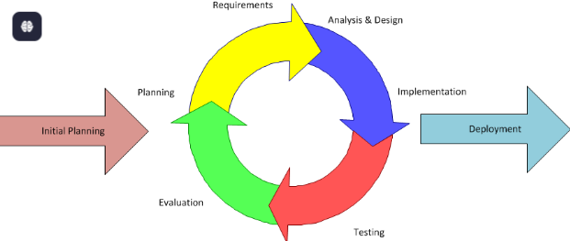
Source: https://www.inflectra.com/Solutions/Methodologies/Hybrid.aspx

Based on Figure 1.1 above, the system lifecycle consists of six iterative phases, with continuous integration and deployment activities occurring throughout the development process.

1.5.1 Requirement Analysis Phase
Conduct meeting with Newton team to gather detailed requirements for the IPAK5 system. This includes identifying operational challenges in stretch-wrapping processes and defining Functional requirements (real-time monitoring, QR scanning, alerts, analytics), Non-functional requirements (performance, scalability, security, reliability), Hardware integration requirements (IoT sensors, machine data communication protocols).

Design Phase
Design the system architecture covering IoT edge-to-cloud data pipeline, Database structure for machine and pallet data, API services for real-time communication, UI/UX design for PWA and mobile applications and Role-based access control and security model:
- IoT edge-to-cloud data pipeline
- Database structure for machine and pallet data
- API services for real-time communication
- UI/UX design for PWA and mobile applications
- Role-based access control and security model

Development Phase
Development will be executed in Agile sprints, where modules are delivered incrementally. Key modules include:
- Machine monitoring dashboard (real-time data visualization)
- QR code scanning for film tracking
- Alert and notification system (email and in-app)
- Data analytics and reporting engine
- IoT device communication layer
- Multi-platform application development (PWA, iOS, Android, Huawei)

Testing Phase
Each platform (Web, iOS, Android, Huawei) will undergo separate validation and certification testing, including store compliance requirements. Testing will be conducted in multiple layers:
- Unit Testing for individual components
- Integration Testing for IoT-device-to-cloud communication
- System Testing for full workflow validation
- User Acceptance Testing (UAT) with operational users

Deployment Phase
CI/CD pipelines will be used where possible to automate build and release processes. Each deployment must comply with platform-specific review and approval procedures. Deployment will be performed independently for each platform:
- Web application deployed to AWS cloud infrastructure
- iOS application deployed via Apple App Store Connect
- Android application deployed via Google Play Console
- Huawei application deployed via Huawei AppGallery Connect

Review & Maintenance Phase
The system will be continuously monitored after deployment to evaluate performance, stability, and user feedback. Activities include:
- Monitoring machine and system performance
- Identifying bugs and operational issues
- Optimizing system efficiency and data accuracy
- Planning future enhancements such as predictive analytics or AI-based optimization

CHAPTER II – DESIGN & DEVELOPMENT

INTRODUCTION

This chapter describes the design and development specifications of the IPAK5 System. It presents the overall system architecture, functional design, database design, user interface design, and system workflows that define how the system operates. The purpose of this chapter is to provide a comprehensive blueprint for the implementation of the IPAK5 system. It explains how the Industrial IoT devices, cloud services, databases, APIs, and multi-platform applications interact to deliver real-time monitoring, analytics, and alert notifications for stretch-wrapping and pallet packaging operations. In addition, this chapter illustrates the responsibilities of each user role and describes the interaction between system components in a structured and easy-to-understand manner. The design specifications serve as a reference throughout the development, testing, deployment, and maintenance phases.

2.1.1 Flowchart Diagram

The flowchart diagram for this IPAK5 system is as shown in Figure 2.1.

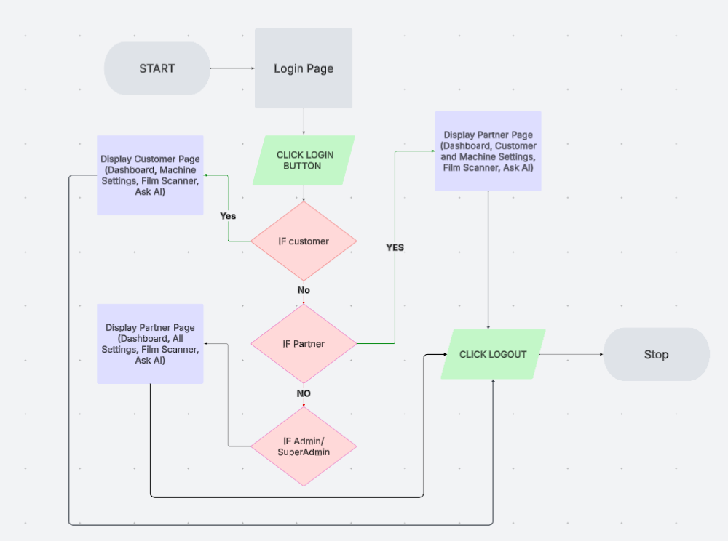

Figure 2.1 Flowchart of IPAK5 System.

2.1.2 User Interface

User Interface refers to the means through which a user interacts with a system, application, or device. It includes visual elements such as buttons, menus, text fields, and icons, as well as interactive components like touch gestures, voice commands, and keyboard inputs.

- Login and Forgot Password
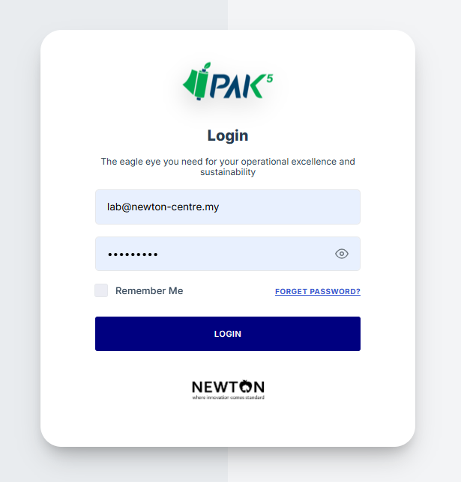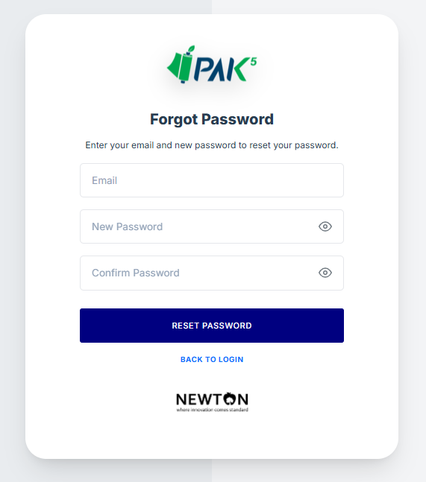

- Dashboard – Packaging Overview
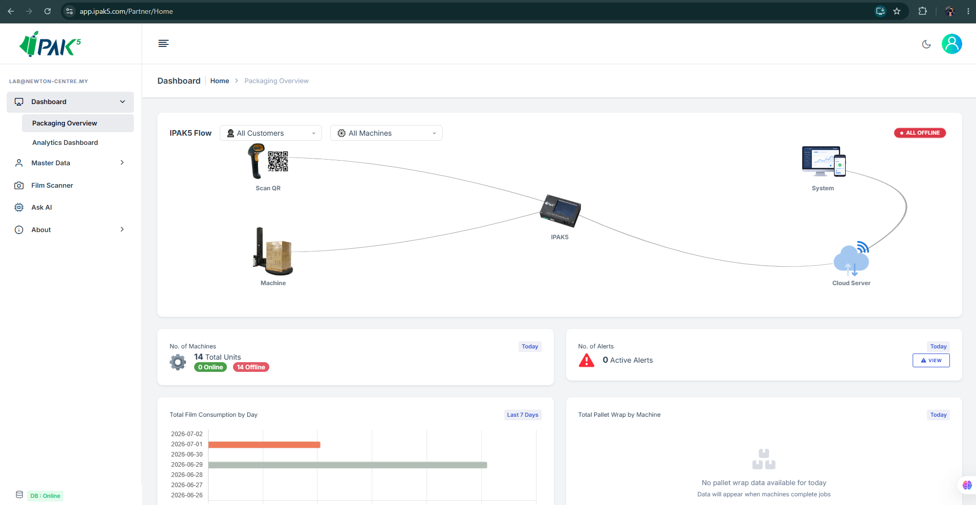

- Dashboard – Packaging Overview
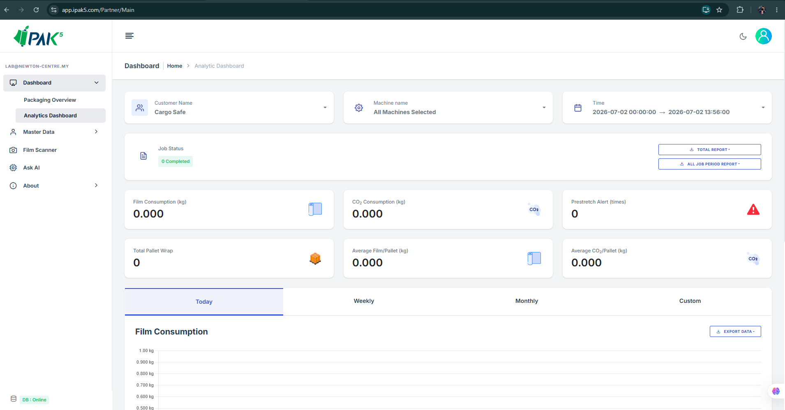

- Machine Settings
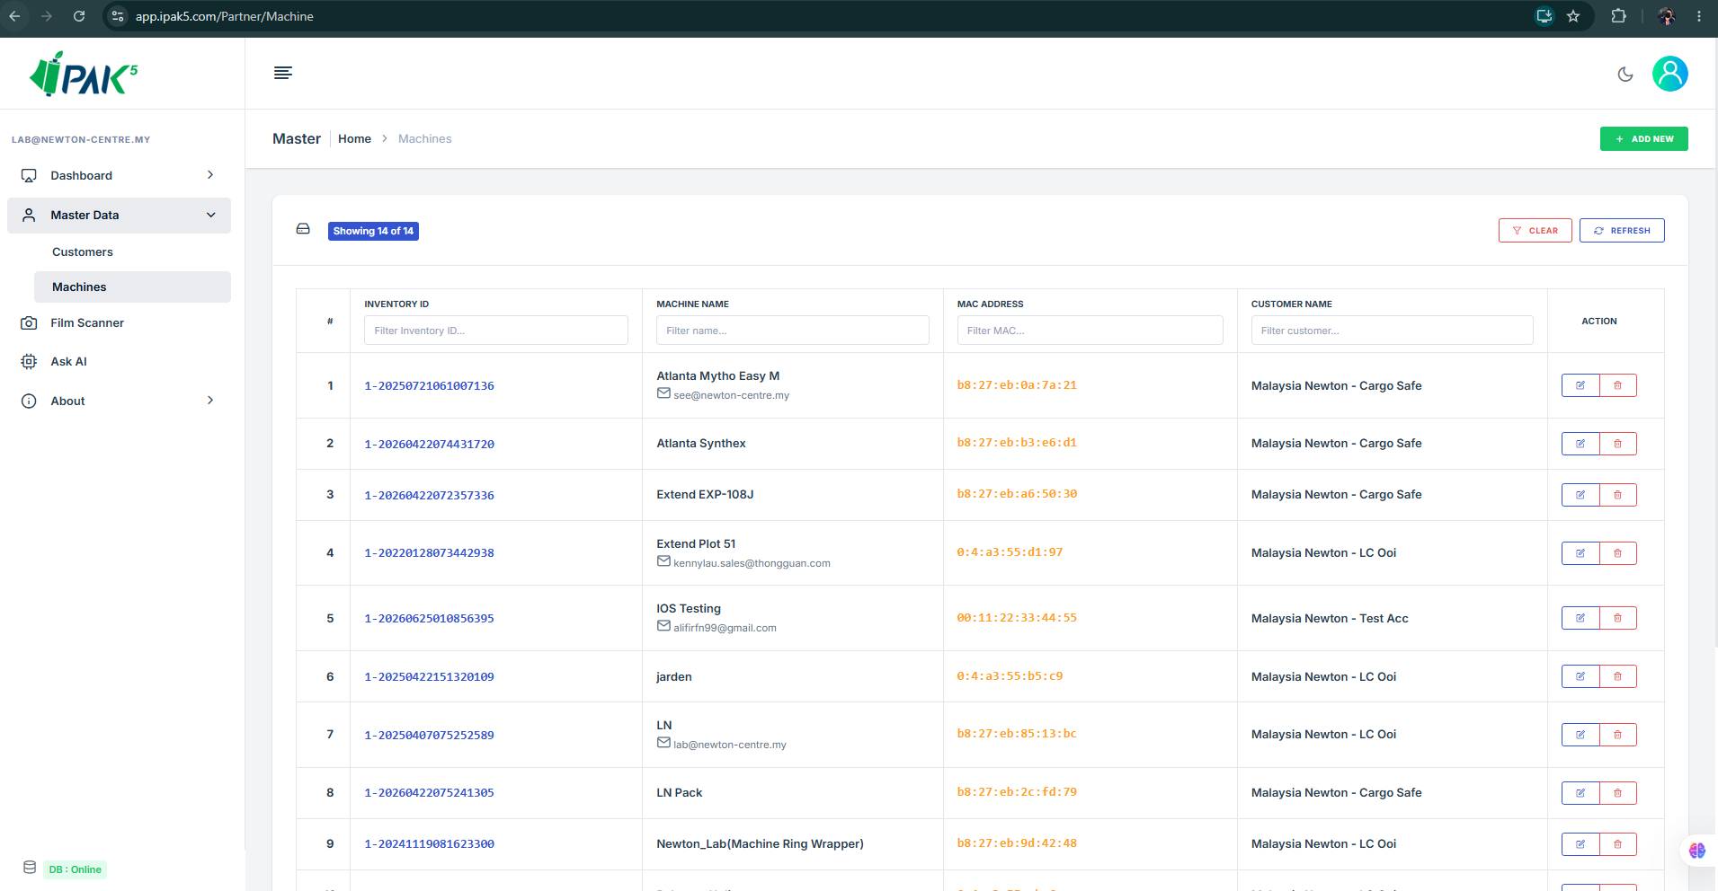

- Customer Settings (For Partner only)
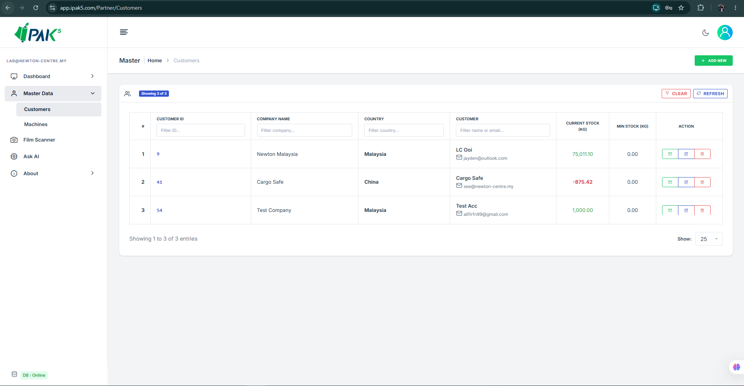

- Film Scanner (Include QR Scanning, Upload Image or Manual Key In)
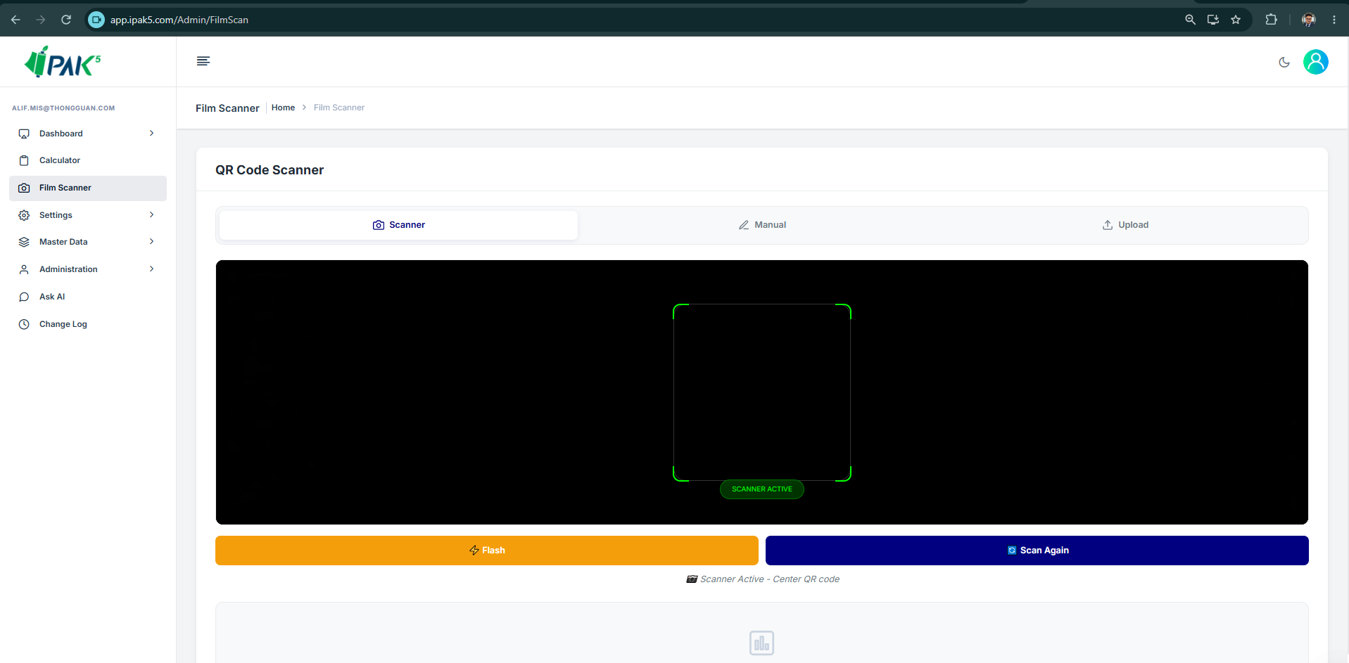

- Ask AI (Include with auto prompt)
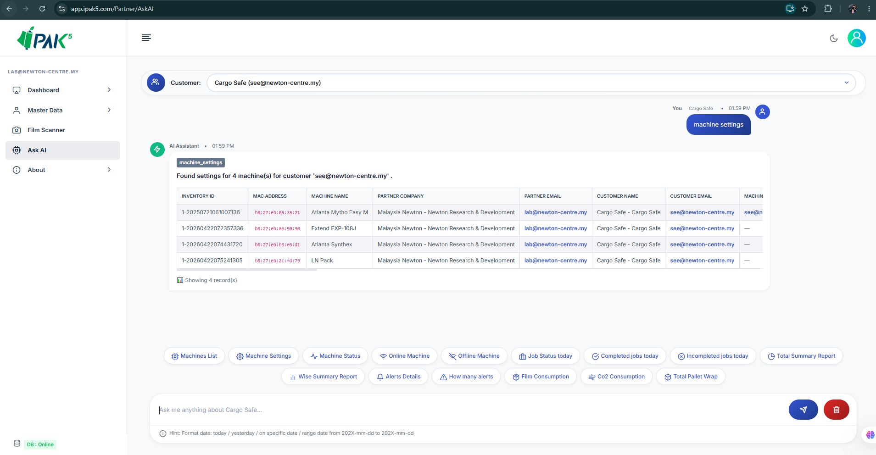

- Profile Update, Company Details, Change Password, Stock Details and Alert Notifications.
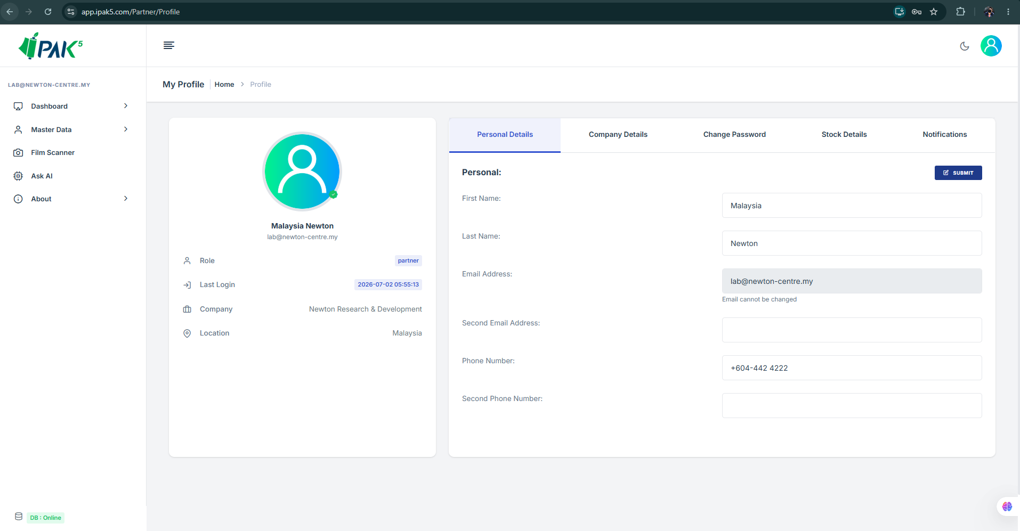

- Android / iOS / Huawei UI
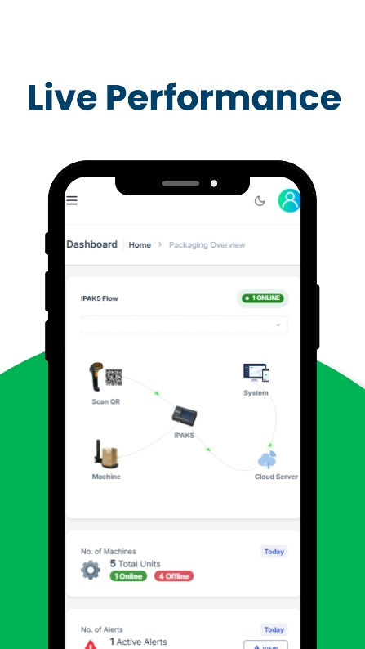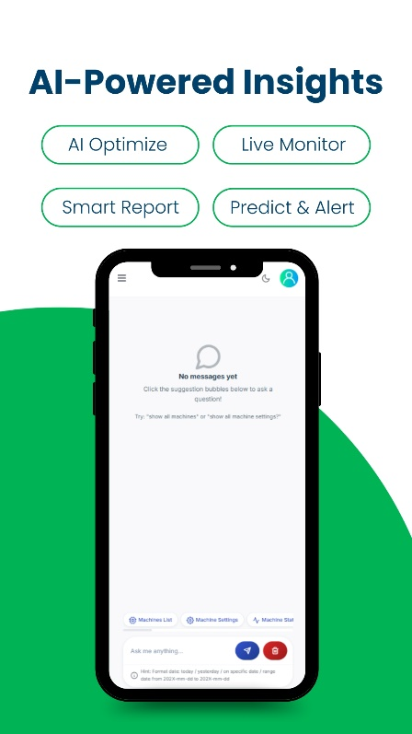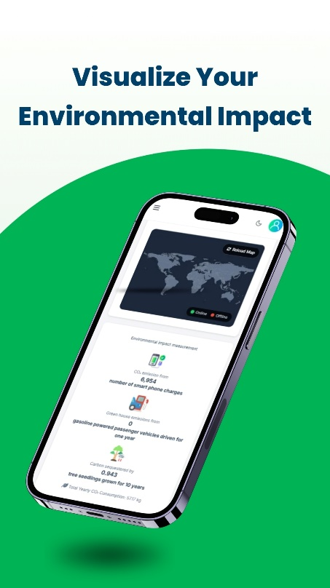

- IPAK5 API module: https://api.ipak5.com/swagger/index.html?urls.primaryName=IPAK5
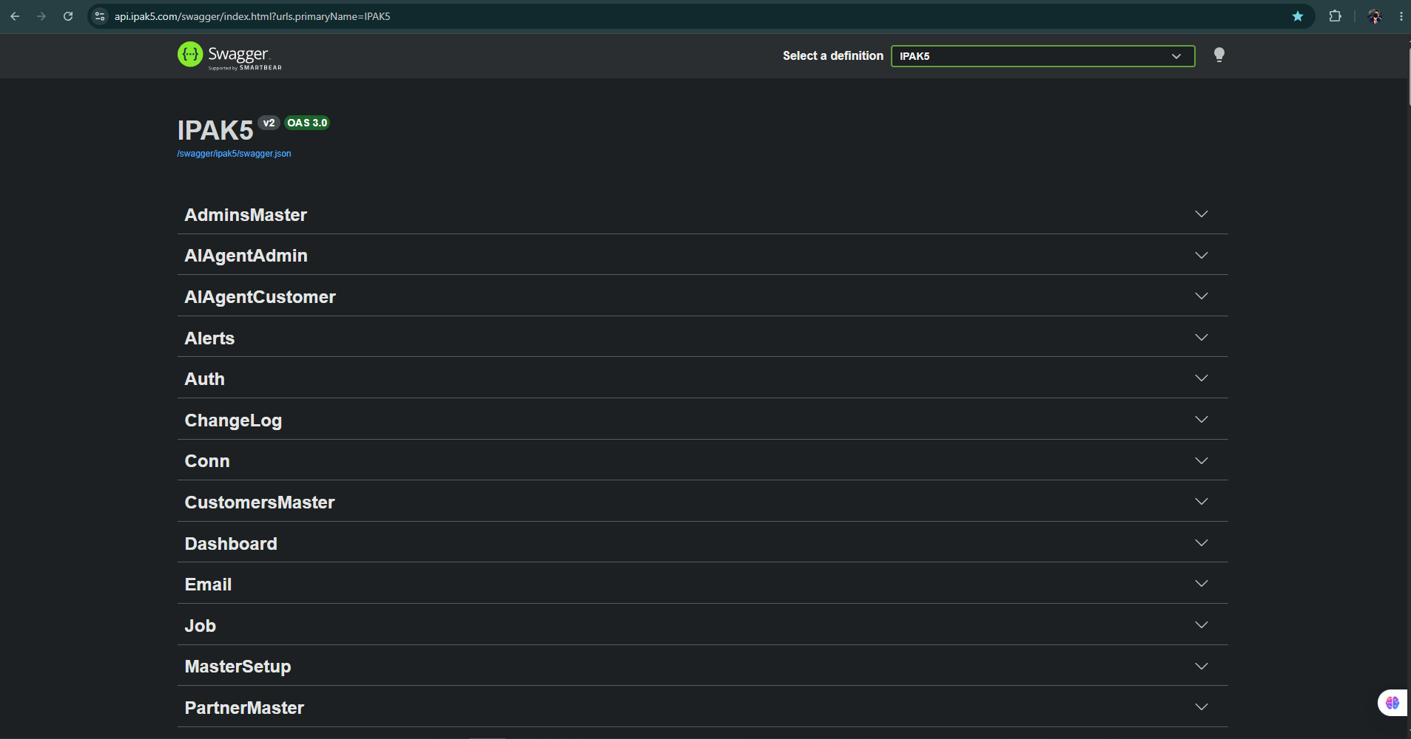

2.4 CONCLUSION

This chapter describes the functional and non-functional requirements of the IPAK5 System. In addition, it provides a more detailed explanation of the system through models such as the use case diagram, use case specifications, and sequence diagram. These models serve to help stakeholders better understand the functions and processes of the system being developed through clear and structured documentation.

CHAPTER III - TESTING & DEPLOYMENT

INTRODUCTION

This chapter describes the testing and deployment activities carried out for the IPAK5 System. The objective of the testing phase is to verify that all system functions operate correctly, meet the specified requirements, and provide a stable user experience across all supported platforms. Testing also ensures that the integration between IoT devices, cloud services, databases, and client applications functions reliably before deployment to production. Following successful testing, the system is deployed to its respective production environments, including the web server and mobile application stores.

TESTING PHASE
Each software module is tested individually by the development team to verify that it performs according to its intended functionality.

3.2.1 Unit Testing
Each software module is tested individually by the development team to verify that it performs according to its intended functionality. Estimated Duration: 3–5 working days. Examples include:
- User authentication
- Dashboard data retrieval
- QR code scanning
- Email notification service
- API communication
- Database operations

3.2.2 Integration Testing
Integration testing verifies communication between all system components. Estimated Duration: 5–7 working days. Example including:
- IoT Device ↔ Cloud API
- Cloud API ↔ Database
- Database ↔ Dashboard
- Email Service ↔ Alert Engine (Bot)
- Mobile Applications ↔ Backend Services

3.2.3 System Testing
The complete IPAK5 system is tested as an integrated solution to validate all functional and non-functional requirements. Estimated Duration: 5–7 working days. Testing includes:
- Real-time machine monitoring
- Stretch film consumption calculation
- CO₂ consumption calculation
- QR code scanning
- Dashboard visualization
- Email notifications
- Historical reports
- User access permissions

3.2.4 User Acceptance Testing (UAT)
End users perform testing using real production scenarios to verify that the system satisfies business requirements and operational expectations. Any issues identified during UAT are corrected before production deployment. Estimated Duration: 5–20 working days (depend on which platform).

DEPLOYMENT SUMMARY
After successful completion of testing, the IPAK5 System is deployed to each supported platform independently.

3.3.1 Progressive Web Application (PWA)
The web application is deployed to the production environment hosted on an AWS cloud server. Since no external review is required, deployment can usually be completed within Estimated Duration: 1–5 working days. Deployment activities include:
- Publish application
- Database migration
- SSL configuration
- Domain configuration
- Production verification

3.3.2 iOS Application Deployment
The iOS application is submitted through Apple App Store Connect for review. The deployment process includes:
- Archive and build generation
- TestFlight testing
- Internal testing
- External beta testing (if required)
- Apple App Review
- Public release
Apple performs a manual review before approving the application. Estimated Duration:
- Internal Testing: 5-7 days
- Apple Review: 2 days
- Bug fixes and resubmission: 1 weeks

3.3.3 Android Application Deployment
The Android application is published using Google Play Console. Deployment activities include
- Closed testing
- Open testing (optional)
- Google Play review
- Production rollout
Google's review process is generally faster than Apple's but still requires compliance verification. Estimated Duration:
- Testing: 2-4 weeks (if reject then it will be until 4 weeks)
- Google Review: 7 days

3.3.4 Huawei Application Deployment
The HarmonyOS application is deployed using Huawei AppGallery Connect. Deployment activities include:
- Build upload
- Internal testing
- Compatibility testing
- Huawei review
- Production release
Huawei performs application security and compatibility checks before approval. Estimated Duration:
- Testing: 2–3 weeks
- Huawei Review: 3–7 days
- Overall Duration: Approximately 3–4 weeks

STATUS DEPLOYMENT

Platform | Deployment Environment | Current Status/Remark | Estimate Duration to Complete
PWA | AWS Cloud Server | - Deployment is currently pending. The user interface (UI) for the Robopac wrapping machine is still under review, and the integration with the Robopac API has not yet been completed.  - Jayden has requested fixes for the dashboard alert issues and improvements to the UI of the Analytics Dashboard. | 7-12 days
iOS | Apple App Store Connect | - The application has been successfully published to the Apple App Store. However, the request to migrate the developer account from an Individual account to an organization account is currently under Apple's review. | 1-3 days
Android | Google Play Console | - The application has been submitted to the Production stage and is currently awaiting Google's review and approval. | 7-12 days
Huawei | Huawei AppGallery Connect | - The application is currently awaiting verification and approval before it can be published on Huawei AppGallery. | 1-3 days

RELEASE NOTE
The system has been released and tested by user; the system will be adjusted from time to time.

Prepared By: | Verified By:
Mohamad Alif Irfan (031545)

